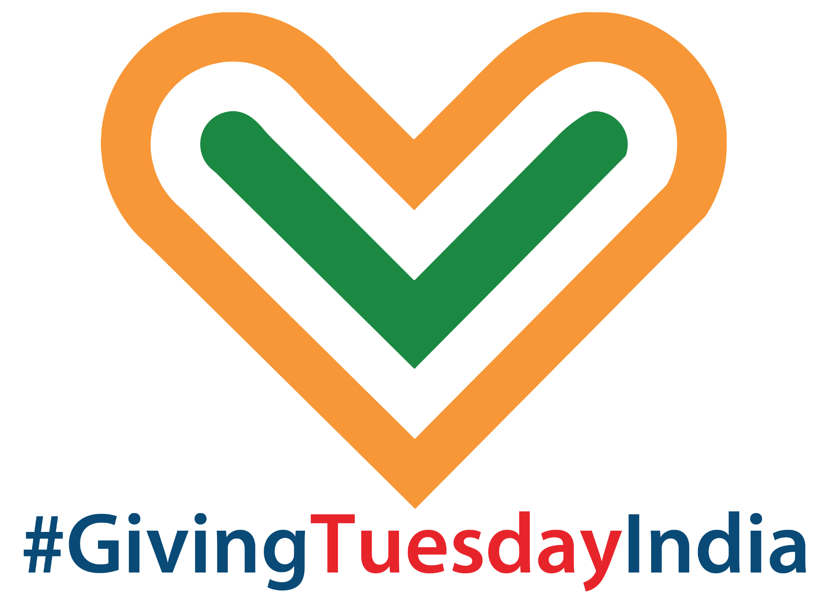
A STEP BY STEP GUIDE TO BUILDING
A SUCCESSFUL CAMPAIGN FOR
NON-PROFITS
#GivingTuesdayIndia



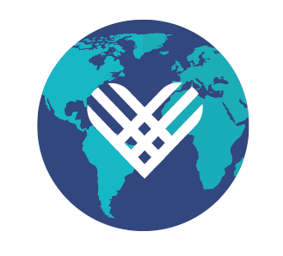
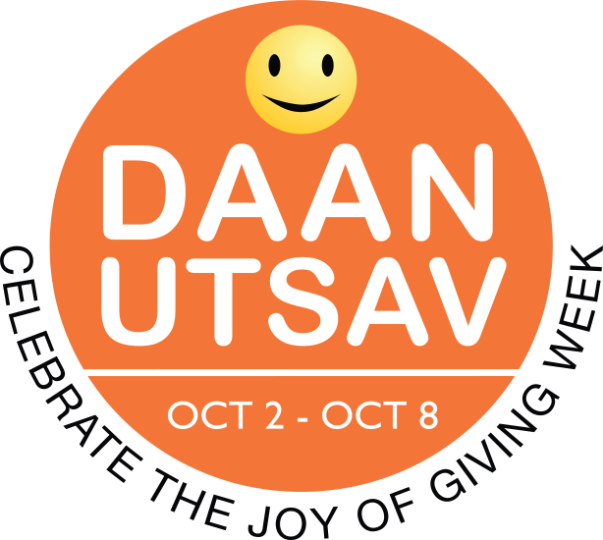

GIVINGTUESDAY INDIA IS PART OF A GLOBAL GENEROSITY MOVEMENT

GivingTuesdayIndia website | Facebook page
Follow @GivingTuesdayIndia and #GivingTuesdayIndia #DaanUtsav on Twitter.

Ready to inspire generosity across your supporters? We’re here to help!

Everyday, the social sector is on the front lines, building stronger, healthier, smarter, and just communities. The sector needs new approaches to keep up with the need - and the digital world. Givingtuesday India is a day to learn, engage, and garner support & fundraise
GivingTuesday was brought to India five years ago, and was positioned as a DaanUtsav celebration, with the Tuesday of the DaanUtsav week (October 2-8 every year) being marked as GivingTuesday in India.
This year it falls on October 4, 2022 and thousands of people across the country will come together on this day, to express generosity by participating in a GivingTuesdayIndia activation or by taking the lead and bringing together communities in generosity!
GivingTuesday is a global giving movement with local impact.
It is an inclusive community of millions of givers, with activity in every country on every continent. We celebrate and uplift grassroots generosity, and generosity as a universally held value. Around the world, across diverse cultures, our network of local leaders in more than 80 countries and hundreds of communities innovate, collaborate, and inspire collective generosity as a way to build the world they want to live in.
It inspires people to take collective action to improve their communities, give back in better, smarter ways to the charities and causes they believe in, and help create a better world. GivingTuesday demonstrates how every act of generosity counts, and that they mean even more when we give together.
Get ready!
In this workbook, you'll tap into the collective experience of GivingTuesday leaders from across the world to learn how to create big impact in India:
- Plan your campaign and recruit a team
- Tell your story so that it inspires support
- Create timelines to organize your planning

Table of Contents
- Approach it like an event

- Set your campaign goal

- Create a work plan

- Organize your campaign team

- Build a campaign brand

- Develop a campaign narrative

- Gather inspiring visuals

- Make an inspiring ask for support or funds

- Identify Campaign Ambassadors

- Delight your Donors with Great Digital Content

- Spur participation with challenges and matching funds

- Plan A Communications Strategy

- We’re here to help, ask us anything

Approach It Like an Event

How do you shift the tone of your GivingTuesday India campaign from obligation to opportunity? Make it joyful. Try new things. Invite new people. Celebrate the change you’re creating in the world.
When done well, GivingTuesday India doesn't feel like another fundraising campaign. We call it GivingTuesday - not FundraisingTuesday - for a reason. It's a day to inspire generosity in all forms, a day for people to generously share whatever they can, whether it is their time, skills, vocalize their support, or money. And if you think about it more like an event, your supporters and potential supporters will feel it too. And, like a well-planned event, these are a few parallels to consider:
- A unifying theme - or goal - creates excitement and engagement, and a framework for decisions (You wouldn't decorate for a Diwali party with a statue of Santa Clause and a Christmas tree and vice-versa).
- It's more fun with old and new friends
- Games and activities can make a big difference
- Sharing memories, as both stories and pictures, and afterwards this keeps the good feeling going, and builds interest and commitment for next year.

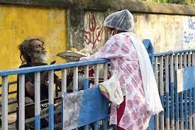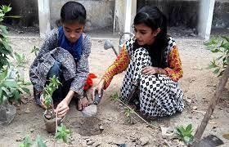
Photo Credit 1: A resident serves food to a pavement dweller in West Bengal_Telegraph pictures; Photo Credit 2: Two girls planting a sapling_ Good Deeds Day Photos

Set your campaign goal
Your campaign goal serves as the campaign framework. Your goal should reflect your team's priorities. It's a great time to experiment with new strategies.

Set a GivingTuesday India/DaanUtsav goal that is ambitious enough that your team will be motivated to achieve it.
Goals can be about a lot more than money. Here are some possibilities.

Potential Goals
Increase Funds | Engage Existing Donors | Engage New Donors
Create Support Amidst Young Donors | Create A Culture Of Monthly Donors | Increase Event Footfalls
Improve Participation in day-to-day workings | Seek Avenues Of Collaborations | Targeted Activations For Social Media Followers
Increase Volunteers | Activity Attendance | Find Creative Ways To Say ‘Thank You’

Write down some ideas for campaign goals here.

What is my goal?

How many?

What event?

Set an activity timeline and meeting schedule

Action | By When? | Done?
Determine team members
Set a kickoff meeting date
Agree on the goal(s)
Divide team into task groups
Create campaign brand
Build communications timeline
Recruit ambassadors
Recruit merchants/ small businesses
Reach out to longtime donors for matching funds
Assemble campaign stories and create outreach
Consider event or an activity for supporters
Let managers lead, likewise organize events to give thanks to everyone within and outside supporting the organisation

Organize your campaign team:
A great campaign will inspire lots of folks to jump on board. Organize your team so that everyone involved knows what's expected and feels great about participating. Make a list of the people you hope to include in your campaign. When they say yes, check them off.

Staff/ Board

Givers/ Volunteers

Amplifiers/Influencers

Community partners (small businesses, PR, marketing)

Build a campaign brand for GivingTuesdayIndia
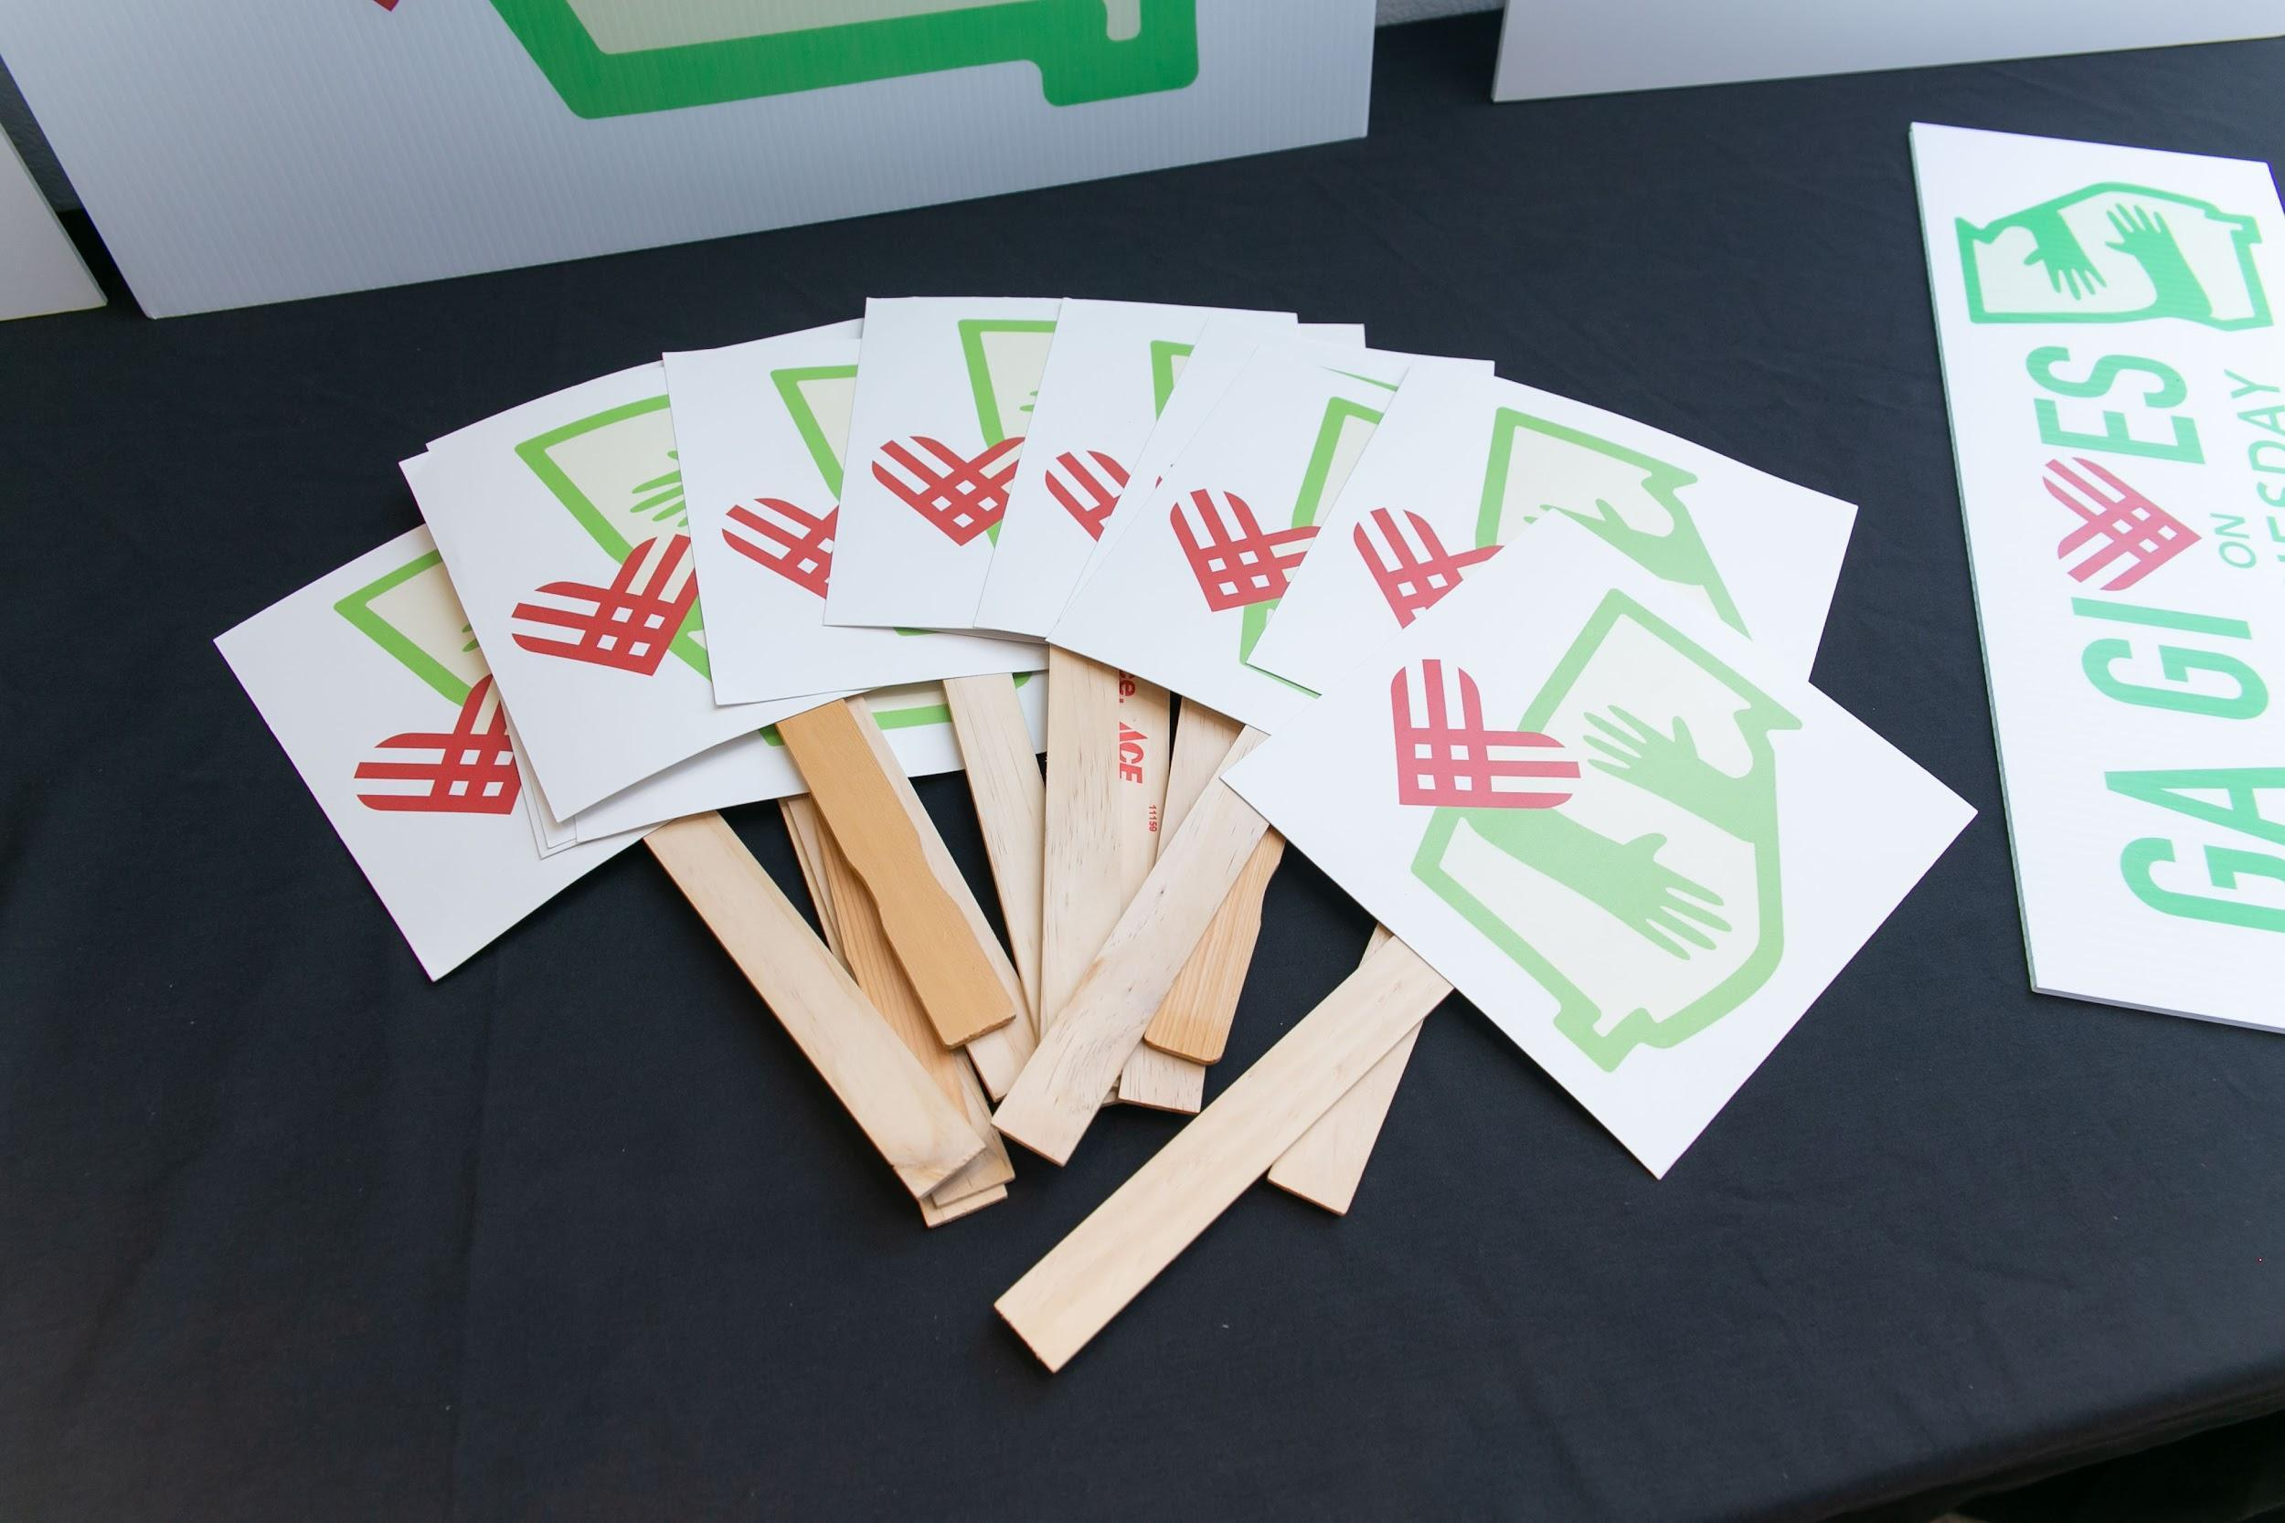

Make GivingTuesdayIndia your own! Design a brand-name, logo, tagline - that will unify your campaign and elevate your marketing. You can access the raw files of our existing logos here
Name
Write down some ideas for a campaign name

Visuals
Write down ideas for brand visuals

Taglines
Write down ideas for a campaign tagline

Develop Campaign Narrative

Narrative Checklist
- Specific program, project, or type of giving
- Iconic story of community member, staff person, volunteer
- Supporting data
- Incorporate matching challenge
- Tie to year-end/Diwali/Christmas appeal

Story Idea 1

Story Idea 2

Story Idea 3

Gather inspiring, authentic visual assets
Visual assets are at the heart of great communications. The logo, color palette, photos, and videos will provide the personality for the campaign and the authentic connection to your work. They don’t have to be perfect!

Make an inspiring Ask!

Use the belief statement + You statement + Opportunity statement to pull a compelling call to action together. | Example: School that is raising funds to build a free one-meal programme for students. Campaign will begin with a story of a student prior to the meal program. Then…  Belief statement: We believe that no student should have to choose between food and learning.  You statement: You can help us stock up on rations so that no student has to make the choice/ goes hungry. Help us run our kitchens.  Opportunity statement: Are you with us?

Belief statement ideas

You statement ideas

Opportunity statement ideas

Identify Campaign Ambassadors

Campaign ambassadors believe in you and are big, credible voices that can amplify your campaign reach.

- Identify ambassadors representing different communities of supporters
- Engage ambassadors by setting aside a day to reach out and then hosting an ambassador meet-and-greet
- Resource ambassadors with engaging, easy-to-share content on a consistent schedule.

Staff and Board | Civic Leaders
Donors/ volunteers | Celebs/ athletes /micro influencers

Who will be responsible for creating content and communicating with ambassadors?

10. Do a tech check!

Make sure that your tech delights your donors.

Pro-tip: Go through your donors' experience on computer, tablet and over the phone. Start with email/social media, click to a website, make an online gift, and review the thank yous. Would your donors be delighted by the experience?

Note any fixes you need to make in the boxes below.

Website, marketing, and donation processing should be reviewed and optimized for the big day/DaanUtsav . All should be simple, intuitive, and welcoming.

Website

Online Giving

Marketing and Outreach, Social Channels

11. Spur participation with challenges and matching funds

Contests, challenges, matching funds and other “gamification” are fun, engaging and make a big difference on GivingTuesday.
Matching Funds: Identify generous donors who can provide funds to spur generosity and progress toward campaign goals. Ask them to consider giving their year-end gift early to support challenges and spur participation. List here:

Challenges and contests create energy and excitement. List challenge and contest ideas here:

12. Plan a robust marketing and communications strategy
Develop a plan to build excitement for your campaign. Consider mail, email, social media, and events. Create exciting, original content and communicate consistently through all of your outreach channels and to your campaign ambassadors.

The plan should be designed around your goals and brand so that all elements of your outreach reinforce each other.

Your marketing can start months before GivingTuesdayIndia. This complete toolkit has a lot of sample templates you can use.

13. Other Resources + Tools for a Successful GivingTuesday India/DaanUtsav
Be sure to check the resource hub at GivingTuesday.org - new tools are added all the time! We also invite you to join the GivingTuesday Learning Lab on Facebook and collaborate with organisations from not just India but from all over the world.

For anything else, reach out to info@givingtuesdayindia.org

