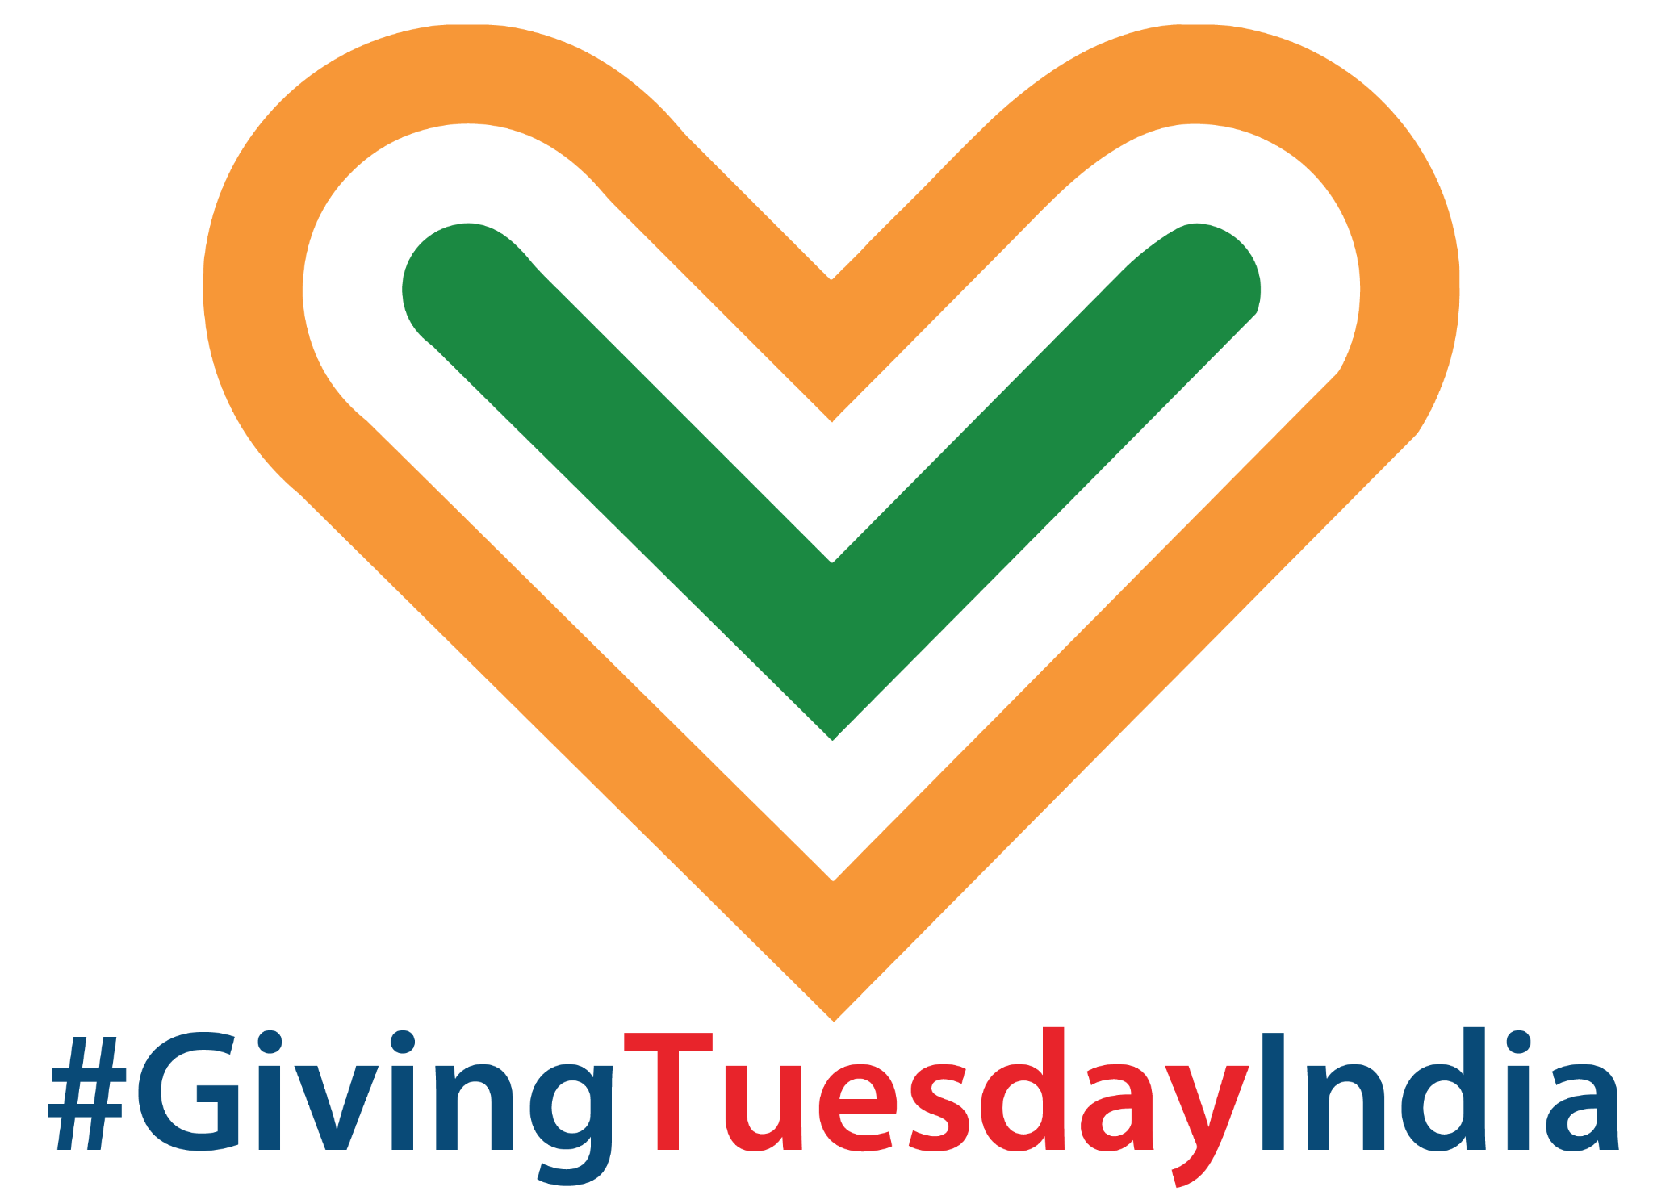
A COMPLETE GUIDE ON PARTICIPATING IN GIVINGTUESDAY INDIA FOR VOLUNTEERS

#GivingTuesdayIndia
October 4, 2022




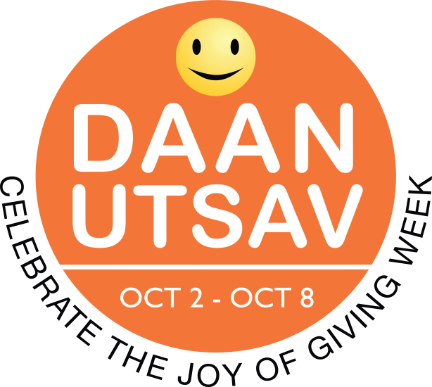

GIVINGTUESDAY INDIA IS PART OF A GLOBAL GENEROSITY MOVEMENT
ROOTED IN DAANUTSAV
GivingTuesdayIndia website | Facebook page
Follow @GivingTuesdayIndia and #GivingTuesdayIndia #DaanUtsav on Twitter.

How to Find a Cause that Matters to You
When you think about volunteering, what inspires you? Why do you want to become a volunteer? What will be different in our world because you gave a little bit of your time as a volunteer?
Tens of thousands of opportunities are available across the nonprofit network every day. Even if you already volunteer, chances are you'll find opportunities that you didn't know existed. Want to feed the hungry? Tutor kids? Help with documentation in an organisation working with tribal people’s welfare?

GivingTuesdayIndia could be a great day to start.

GivingTuesday was brought to India five years ago, and was positioned as a DaanUtsav celebration, with the Tuesday of the DaanUtsav week (October 2-8 every year) being marked as GivingTuesday in India. This year it falls on October 4, 2022 and thousands of people across the country will come together on this day, to express generosity by participating in a GivingTuesdayIndia activation or by taking the lead and bringing together communities in generosity!

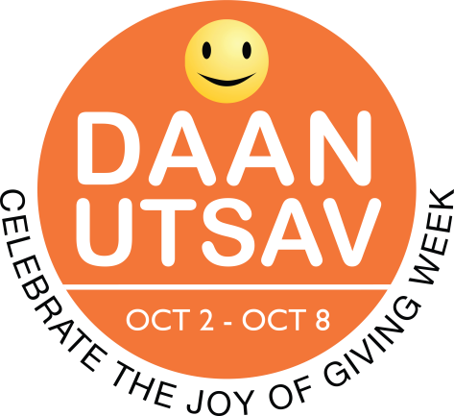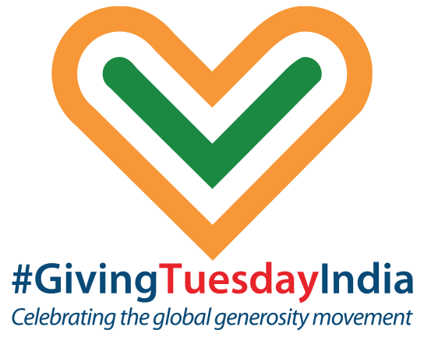

While it may at first seem as though the motivations for giving your time are pretty straightforward, there are as many reasons to give back as there are humans.
People volunteer for a variety of reasons. Some are motivated by altruistic values, some seek social justice, and others see service as a way to enable a democratic political system. Whatever your reason, we believe volunteering can transform you and the world around you.

15 Great Reasons to Volunteer
- Help others
- Make a difference
- Find purpose
- Connect with your community at large
- Feel involved
- Contribute to a cause that you care about
- Use your skills in a productive way
- Develop new skills
- Meet new and good people
- Explore new areas of interest
- Expand your horizons
- Get out of the house
- Make new friends
- Strengthen your resume
- Feel better about yourself

When you give back — of your time, your talents, or your treasure — you create a special connection with the people and communities you care most about. Share how you’re pledging to give your time on social media and be sure to tag @daanutsav and @GivingTuesdayIndia and use the hashtag #GivingTuesdayIndia #daanutsav
There are plenty of good causes to dedicate your time to this year.

Add GivingTuesday to your calendar!

How to find opportunities
- This GivingTuesday India reach out to the organisation whose cause you feel most passionately for: mail/call/walk into the office and offer your time and skills. They will surely find a way to accommodate you into their project schedule.

Attached is a sample email you can send to the organisation of your choice:

Subject: Application for Volunteer Work

Dear Sir/Madam,
This is {Your Name}. I am interested in joining your institute on an honorary basis for the betterment of {Cause}. I would appreciate it if I am provided an opportunity to play some part in making a difference in the lives of {Group affected}. I would like to start on GivingTuesday India (date on the particular year) and use my time volunteering with you as a pledge and to show solidarity with the GivingTuesday Movement.
Please find attached my CV (Also mention in 2-3 lines your education qualifications and 3-4 core skills). (Do mention the amount of time you would be able to offer along with any other constraints, such as not being able to work on-site and seeking a remote opportunity).
Thank you and Awaiting Your Reply.
Regards,
(Your name and contact details)

- Find groups on whatsapp/facebook and pages on instagram that frequently post and circulate volunteer positions. Apply to ones you find most connected with.
- Put out feelers amongst your social and professional networks on LinkedIn and whatsapp. Clearly state the causes you’re keen on, the time commitment and the kind of work you’d be willing to volunteer your times towards starting this GivingTuesdayIndia day.
- Identify a problem in your own neighbourhood and gather a group to resolve it, like cleaning up a dump yard or street, putting out water bowls for birds, cleaning up a beach, beautifying a public park/wall, creating a solution for traffic congestion on a particular street, volunteering to help people cross the road etc this GivingTuesdayIndia day.

Sample Messages To Grow Your Tribe
Be sure to share - the power of social proof is immense and by sharing, you’re inspiring others in your network to help!

Twitter
- I’m volunteering my time to ____ today for #GivingTuesdayIndia - a #DaanUtsav festival! Join me and let’s work together to make our world a better place!
- Join me and millions around the world in giving back, spreading kindness, and showing how together we can be a force for good on #GivingTuesdayIndia

Facebook/Instagram
- Today, for #GivingTuesdayIndia, I’m volunteering my time to _____. This cause is important to me because ______. Join me! Here’s the link to sign up.

Canva Graphics
Use our Canva templates and share where you’re giving on GivingTuesdayIndia or use your own images. There’s nothing like an unselfie while volunteering! Customize and tag with your favorite nonprofit.

