
A COMPLETE GUIDE ON PARTICIPATING IN GIVINGTUESDAY INDIA FOR EDUCATIONAL INSTITUTIONS

#GivingTuesdayIndia
October 4, 2022





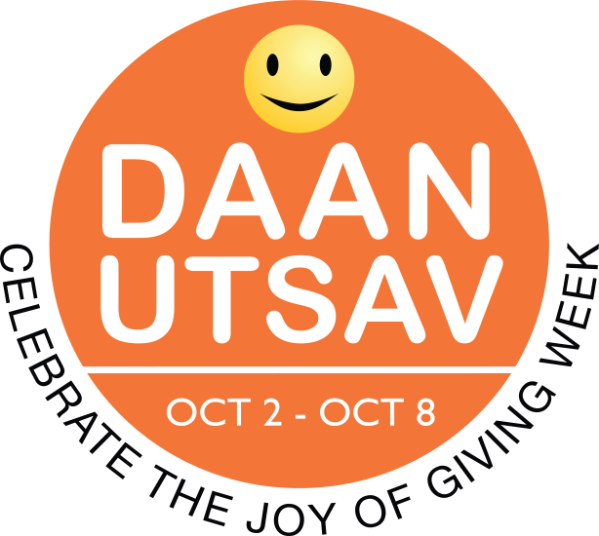

GIVINGTUESDAY INDIA IS PART OF A GLOBAL GENEROSITY MOVEMENT
ROOTED IN DAANUTSAV
GivingTuesdayIndia website | Facebook page
Follow @GivingTuesdayIndia and #GivingTuesdayIndia #DaanUtsav on Twitter.

Introduction
‘Giving’ is not a new phenomenon for India. The culture of philanthropy, which has a history spanning thousands of years, is as old as India itself. This is further reinforced by eastern religious philosophies, according to which, “giving” is viewed as a key part of one’s social duty. GivingTuesday’s values, to this end, easily ties in with India’s existing cultural ethos.
GivingTuesday was brought to India five years ago, and was positioned as a DaanUtsav celebration, with the Tuesday of the DaanUtsav week (October 2-8 every year) being marked as GivingTuesday in India. This year it falls on October 4, 2022 and thousands of people across the country will come together on this day, to express generosity by participating in a GivingTuesdayIndia activation or by taking the lead and bringing together communities in generosity!
It is a day that provides opportunities for people around India, to use their individual power of generosity, to remain not only connected with each other, and support those around them; but also prove an opportunity to reconnect with their own cultural roots. What’s more, according to research, giving makes us happier. And who wouldn’t want that. Apart from this, the best way to lifelong emotional well-being is to feel connected—to family members, friends, members of your immediate and extended community. To this end, GivingTuesday India is a day when everyone comes together to give back in all forms: via acts of kindness; advocate on behalf of a cause; volunteer their time and talent or offer a monetary donation.

Key Messages
How to talk about GivingTuesdayIndia
GivingTuesday is a global generosity movement that started in 2012 as a simple idea: a day that encourages people to do good. Over the past 10 years, it has grown into a global movement that inspires hundreds of millions of people to give, collaborate, and celebrate generosity year- round. In India, GivingTuesday is celebrated as part of the week-long festival of giving, DaanUtsav (Oct 2 - Oct 8).

Like Gandhi’s freedom movement, this too is a people driven movement.

- GivingTuesday is an opportunity for people around the world to stand together in unity⁠⁠—to use their individual power of generosity to remain connected and heal.
- People can show their generosity in a variety of ways during GivingTuesday⁠⁠—whether it’s helping a neighbour, advocating for an issue, sharing a skill, or giving to causes, everyone has something to give and every act of generosity counts.

GivingTuesdayIndia

An opportunity to bring in support for a cause close to your heart

This guide provides some ideas and basic organising tactics you can use as members of an educational institution, in your capacity as a teaching staff or student, to bring together your students (for teachers) and peer groups (for student) and gain support for an organisation working in a cause that you feel passionately for on GivingTuesday India this October 4, 2022.
As a student, you can use this opportunity to pick up invaluable leadership skills, while developing empathy and doing your bit for society.
And as a teacher, by encouraging your students to participate in a global movement such as GivingTuesday, you're not only improving their worldview and instilling in them the value of service before self but also teaching them gratitude, a feeling we all could do more of to bolster our sense of wellbeing and confidence.
As an educationist, in encouraging your students to give back, you'll be doing an important service to humanity by helping to raise empathetic citizens.
We have listed out a few ways you can give back.

As a Student:
Students around the world have done their bit and you too, in India, can.

Raise Funds

Day’s Wages
Students can earn through everyday chores, such as washing cars and bikes, running errands, etc. and donate their earnings to an NGO of their choice on GivingTuesdayIndia.
Street Plays
College students can stage street plays on socially-relevant topics to raise awareness, they can also solicit funds during these and contribute to an NGO of their choice on GivingTuesdayIndia.
Joyfest
College students can encourage their student bodies to donate part of the proceeds from their college fests to a noble cause on GivingTuesdayIndia.
Donation Box
Get a donation box set up at the canteen or anywhere on campus where change is tendered to encourage everyone to drop their loose change into the box representing the cause of their choice on Giving Tuesday India.
Raise Your Voice
Shine Light on Issues
Each student can raise awareness about a social problem on social media on GivingTuesdayIndia and create support groups that can further put pressure on the local political bodies that be. The problems can range from potholes or garbage collected or lack of lighting or dividers on streets, etc.
Health Awareness Drives
College students and high school students conduct awareness drives on health and hygiene in nearby slum/village areas, in partnership with a local NGO on GivingTuesday.
Start a Road Safety Campaign
College students and high school students can conduct road safety campaigns at traffic signals with activities, such as appreciation badges for law-abiding/helmet-wearing motorists on GivingTuesday.
Raise a Helping Hand
Beautification Drive
Organize an event where students come together to beautify public spaces, such as compound walls, bus stands, stations, parks, government school's facades, government hospitals, shelter homes, etc. Pick one and get it done on GivingTuesday India.
Clean up drive
Organize an event to clean-up public spaces, such as beaches, stations, parks, government hospitals and schools on GivingTuesday India.
Two Good
Divide yourselves up in groups of two and volunteer on GivingTuesday India. For instance, you and a friend can go to the nearby community school and offer a lesson on a subject of your choice.

As a Teacher:
- Discuss with your students what social issues matter most to them. Invite your students to develop their own class or individual projects to present it to the class on a generosity on GivingTuesday India. This can be a great way to raise more socially aware citizens.

- This project could include not only a presentation element, by way of advocacy, but a live-action one too. Organise a field trip where the entire class decides to come together to volunteer at one organisation on GivingTuesday India. For instance, everyone could go to an old age home and spend the day caring for the elderly.
Here are a few ideas to get the ball moving:
- Combating climate change: clean up a neighbourhood playground, park, public ground or beach; plant a garden; harvest fruits & vegetables; or plant trees on your school or university campus.

- Support other young people: collect and donate school supplies; run a toy drive on Giving Tuesday India, visit a children’s hospital

- Helping with in-kind donations: prepare care kits by pooling funds towards items and donate these to an NGO on GivingTuesday India.

- Animals: volunteer at an animal shelter; set up a donation drive to support animals in need; advocate for animal adoption on GivingTuesdayIndia

- Hunger and tackling food insecurity: Come together as a team, your classroom full of students and you can prepare or source food packets and give them out to the homeless on GivingTuesdayIndia.

- Social justice and fighting inequity: help your students organise themselves and write letters to elected officials about a local policy change and send them out from the campus itself on GivingTuesdayIndia. Institutional backing holds great weight.
Don't forget to take photos and short videos of your project in action and share on social media using #GivingTuesdayIndia.
Note: Sharing on social media is optional, we respect children’s privacy. Doing the project and learning how amazing it feels to give, is the more important part!

