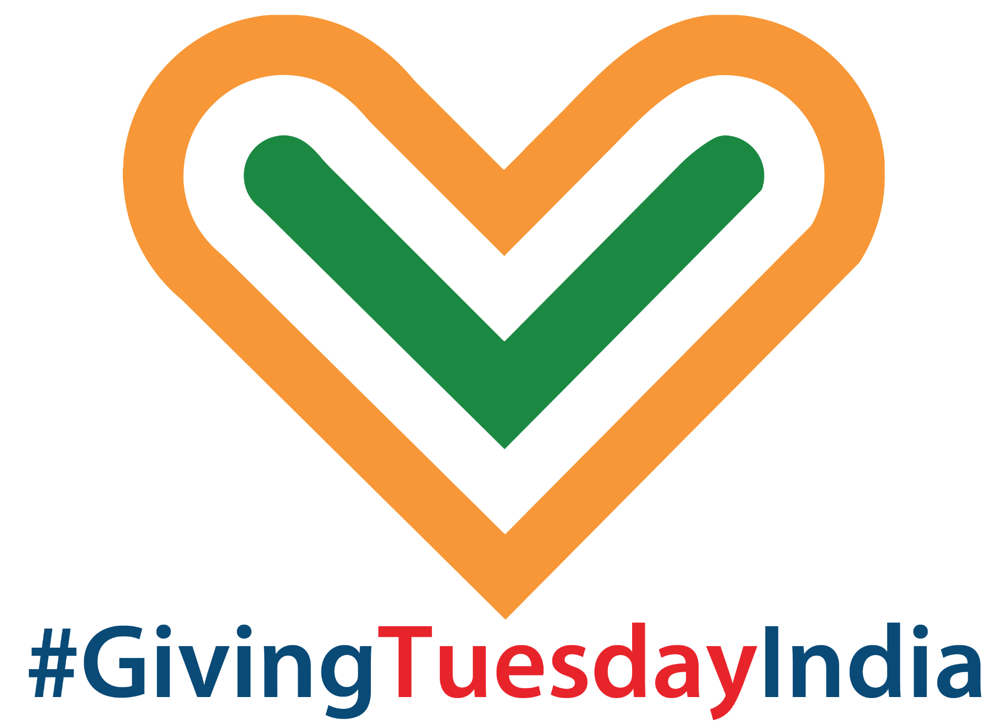

A COMPLETE GUIDE ON PARTICIPATING IN GIVINGTUESDAY INDIA
FOR BUSINESSES

#GivingTuesdayIndia
October 4, 2022






GIVINGTUESDAY INDIA IS PART OF A GLOBAL GENEROSITY MOVEMENT
ROOTED IN DAANUTSAV
GivingTuesdayIndia website | Facebook page
Follow @GivingTuesdayIndia and #GivingTuesdayIndia #DaanUtsav on Twitter.

Businesses are the lifeblood of any community, as the places where we work, eat, shop, play and gather. On GivingTuesday, businesses, both large and small, around the world will once again come together for those in need.
This toolkit contains ideas for how your business can participate in GivingTuesdayIndia, it will include sample social media messages, emails, and more to make it easier for your business to give back.
GivingTuesday was brought to India five years ago, and was positioned as a DaanUtsav celebration, with the Tuesday of the DaanUtsav week (October 2-8 every year) being marked as GivingTuesday in India. This year it falls on October 4, 2022 and thousands of people across the country will come together on this day, to express generosity by participating in a #GivingTuesdayIndia activation or by taking the lead and bringing together communities in generosity!

GivingTuesday is about giving of all types — some businesses may choose to give a financial contribution to their favorite cause or organise a fundraising drive, others will opt to reach out to neighbours, start an awareness campaign, donate goods or extra supplies, and share gratitude within the community.
If you can show generosity and share kindness, you have something to give!
There are many ways businesses can be a part of this global day of generosity by using their platforms, talents and resources for good.

Here are a mix bag of ideas for businesses, both big and small:
- Banks and financial institutions can use their ATMs to display awareness messages and support one or many NGOs across the country, on GivingTuesday India. They can also enable donations to charity via QR codes in the ATM itself, which, when scanned, could offer up a plethora of causes individuals could donate funds to.
- On October 4, banks and payment wallet services can offer to make a small donation (say Rs 1 towards an NGO’s cause) every time a user swipes their card or makes a UPI donation. In advertising this, they would also be encouraging the generosity of their patrons who may not only use their digital payment modes more but also be tempted to donate something themselves.
- On GivingTuesday India, every time a user makes a UPI transaction, they can be asked, via a tick-box, if they would like to donate to one of the partnering causes.
- Customer-facing companies can host banners featuring causes on their website and on the footer of their emails on GivingTuesday India, encouraging them to donate via the company’s site or voluntarily.
- Banks can conduct free seminars on the importance of wills and how to donate to a charity through a will on GivingTuesday India.
- Telecom service providers can use messaging/notifications to promote GivingTuesday India. They can also promote specific campaigns or run their own giving campaign via these channels.
- Airlines can enable inflight donation to preferred charity on GivingTuesday India. Messaging on GivingTuesday India can also be done through inflight magazines and on boarding passes, etc.
- Companies can launch organic social media campaigns and offer to make a donation for every user engagement on the campaign.
- FMCGs can create special charity packs that customers can buy and donate. For instance, a hygiene pack can contain soap, oil, detergent, toothpaste, toothbrush, shampoo, talcum powder and menstrual pads. The products are offered at substantial discount to MRP and packed differently, in line with the organisation being donated to, in this case a shelter for destitute women; thereby promoting the spirit of GivingTuesday India.
- Run campaigns designed around the brand’s values, encouraging viewers to celebrate GivingTuesday India through their own acts of giving: funds, time and voice.
- If you have a storefront, coordinate a drive of specific goods and coordinate pickup with a nonprofit that can get them to the right people on GivingTuesday India.

- Share kindness: have employees check on those who are alone, perhaps, their neighbours, the elderly or may need help with errands or a friendly call on GivingTuesday India.

- Offer your employees a paid leave on GivingTuesday India, so that they can volunteer.

- In your business front, post a poster/sign of support for a cause on GivingTuesday India. You can also feature an NGO of your choice.

- Use your social channels to encourage others to share kindness and generosity on GivingTuesday India.

- Offer discounts on your products on GivingTuesdayIndia and offer the discounted amount as a contribution to an NGO you support. For instance, if a customer buys a product, you can say either 'x' amount from it will be contributed to a cause. Or if the product is offered at a 5 percent discount, upon sale, this 5 per cent will be contributed to an NGO on #GivingTuesdayIndia.

- Have an employee or team with a special talent(s) or skill, consider sharing it with others, such as by offering a free training session on GivingTuesday India.

- Gyms can offer a donation match for every calorie burnt by a client whilst working out on Giving Tuesday India. For instance, if a customer burns 100 calories, the gym contributes Rs 100 towards a cause on GivingTuesdayIndia.

- Host a Give old, Buy new offer on GivingTuesdayIndia where retail shops provide a space for customers to drop off their old clothes, accessories, phones, etc. and offer them significant discounts in exchange.

Hospitality Sector:
- Make a few extra dishes or package excess inventory and give to a few elderly neighbors or essential workers. Or to an orphanage nearby.
- Organise a Dine Out, Do Good offer by tying up with an NGO. Commit to giving a portion of sales to charity on GivingTuesdayIndia. Likewise, banks and wallets can make a small donation (say Rs 5 for a midday meal), every time a user swipes their card.
- If you are a hotel, keep donation boxes/QR codes in each room on your property, where guests can leave behind a small donation on GivingTuesday India.

In-Store Ideas
- Make sure to promote your GivingTuesday activity with store signage
- You can also run a donation drive on GivingTuesdayIndia. Collect non-perishable food or home goods to bring to a nonprofit’s collection. And be sure to take lots of photos along the way so your customers can see how big of a collective impact they helped you make.
- Create a new product, flavor, or coffee brew in honour of GivingTuesdayIndia. Anything from ice cream flavours, signature dishes, to beverages. Offer up the proceeds on this special edition to an NGO of your choice.

SIMPLE WAYS TO SPREAD THE LOVE

Social Media Ideas
- Post an #Unselfie–a post on social media that shares a message about why your business gives back and what you are passionate about
- Create an online fundraiser for your favorite organisation or support current efforts of a nonprofit your business cares about
- Change your business’s Twitter display name to show your support for a nonprofit or a community.
- Add Facebook frame to your profile to show that you’re giving back for GivingTuesdayIndia.
- Add an Instagram donate sticker to your story
- Share a story about who is inspiring you to help and why your community is so important to you
- Use our “Together we…” theme to share ideas how together we can help.
- Add a link to a favorite nonprofit in your instagram profile.
Connect with us so we can help boost your ideas!
- Talk about giving and generosity using the hashtag #GivingTuesdayIndia and #ShopLocal
- Follow @GivingTuesdayIndia on social media

Email Templates
Email is one of the most effective ways to communicate with your audience this time of year. To make sure your subscribers don’t miss a thing you’re doing this festive season, we recommend sending a 5-email campaign:
Email #1: Give your subscribers a heads up as soon as you can, letting them know about your special offers on October 4, Giving Tuesday India.
Email #2: Send an email on October 4, Giving Tuesday India. Let your audience know about a cause you care about and encourage them to donate or volunteer.
For instance, Banks enable users to donate to chosen charity through their website and payment apps, by sending out mailers, messages and notifications.
Or, you could even lead a volunteer group and let your audience know your store will be closed so you can spend time giving back to your community. Consumers want to support brands that give to others and do their part to make their community a better place.

Sample Social Media Messages

Twitter
- We are showing our support for [cause/nonprofit] this October 4, 2022 for #GivingTuesdayIndia. Together we can heal the world.
- We are proud to stand with people around the world in raising awareness & support for those helping our community. Join us giving back this #GivingTuesdayIndia: https://givingtuesdayIndia.org.
- Join me and millions around the world in giving back, spreading kindness, and showing how together we can be a force for good on #GivingTuesdayIndia: https://givingtuesdayIndia.org.

Facebook/Instagram/LinkedIn
- We are showing our support for [cause/nonprofit] this October 4, for #GivingTuesdayIndia. Together we can give back.
- We are proud to stand with people around the world in raising awareness & support for those helping everyone in need. Join us giving back this #GivingTuesdayIndia: http://givingtuesdayIndia.org.
- Join me and millions around the world in giving back, spreading kindness, and showing how together we can be a force for good on #GivingTuesdayIndia on givingtuesdayindia.org.

