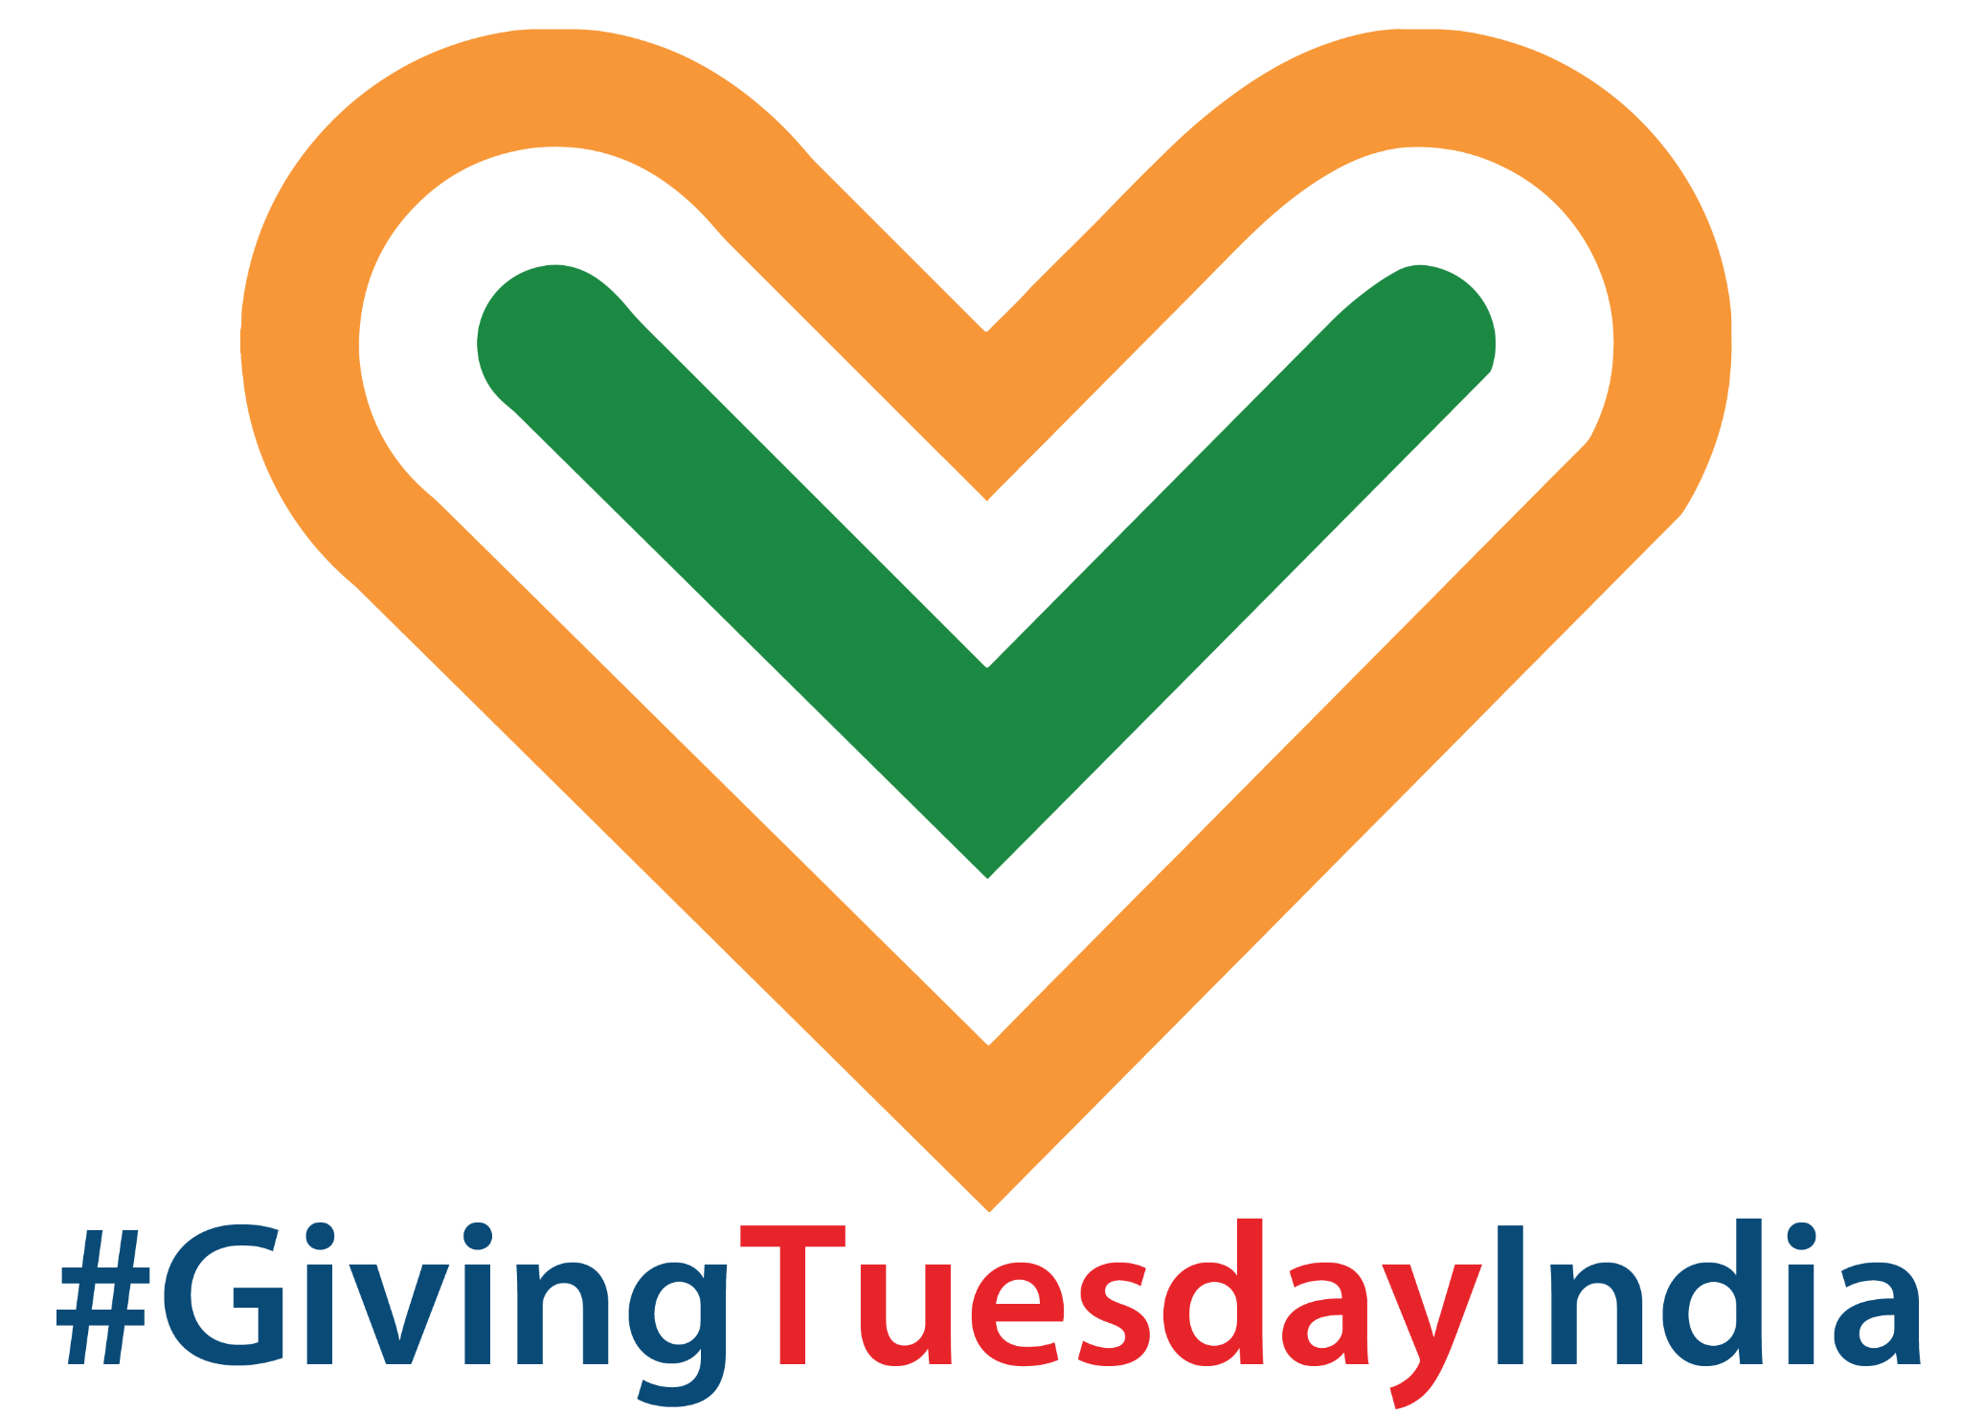
A COMPLETE GUIDE ON PARTICIPATING IN GIVINGTUESDAY INDIA
FOR BRANDS & COMPANIES

# #GivingTuesdayIndia
October 4, 2022



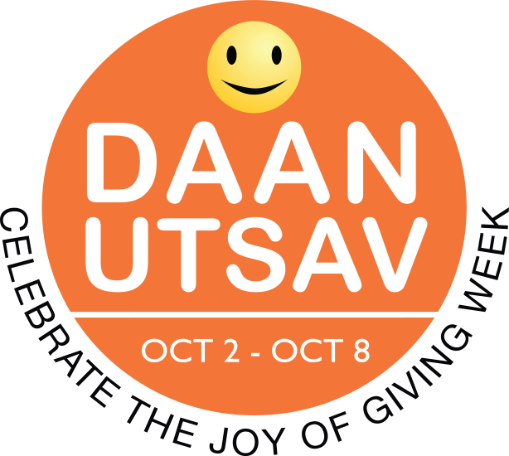
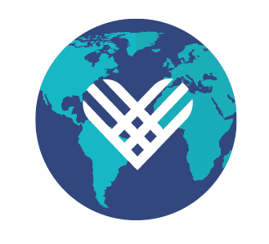

GIVINGTUESDAY INDIA IS PART OF A GLOBAL GENEROSITY MOVEMENT
ROOTED IN DAANUTSAV
GivingTuesdayIndia website | Facebook page
Follow @GivingTuesdayIndia and #GivingTuesdayIndia #DaanUtsav on Twitter.

Key Messages
How to talk about GivingTuesdayIndia

- GivingTuesday is a global generosity movement, unleashing the power of people and organisations to transform their communities and the world.
- GivingTuesday was created in 2012 as a simple idea: a day that encourages people to do good. GivingTuesday was brought to India five years ago, and was positioned as part of the DaanUtsav celebration, with the Tuesday of the DaanUtsav week (October 2-8 every year) being marked as GivingTuesday in India.
This year it falls on October 4, 2022 and thousands of people across the country will come together on this day, to express generosity by participating in a #GivingTuesdayIndia activation or by taking the lead and bringing together communities in generosity!

- People can show their generosity in a variety of ways during GivingTuesdayIndia: whether it’s as simple as helping out a neighbour; speaking in support of an issue; sharing a skill for greater good; or donating to one or many causes: every act of generosity counts.

Add GivingTuesdayIndia to your calendar!

Why It makes Good Business sense to DO GOOD
Being public about your values is good for your business and good for the world. It makes your consumers and partners feel like they have aligned themselves with a brand with a conscience. Owing to this, it passes on to the commercial brand a deeper meaning and offers another opportunity for engagement with their customers on a different emotional level.

Some quick facts about brands and giving back:

64% of people consider themselves “belief-driven buyers”, according to a 2020 study by international PR consultancy Edelman— meaning they will choose, switch, avoid or cancel a brand based on its stance on social issues. (source)
93% of customers are loyal to companies that address social causes.

91% of people are ready to switch their brand based on social issues.

90% are more likely to try a product from a person or company that takes a stand on social and political issues. (source)

80% are willing to pay MORE for a product or service from a brand that’s public about their social and political values (source)

85% of customers respond more favourably to businesses that support causes they care about. (source)

Employee turnover can be reduced by over 50% if volunteering as a team is championed by the organisation. This creates connections between employees. It’s a great team building activity, expanding creativity and happiness.

79% of employees prefer to work for socially responsible companies and think it’s important that companies match their charitable giving. (source)

Taking a stand and giving back to causes builds trust, connection, and long-lasting relationships. It demonstrates that you have values and goals beyond revenue, and it’s an expression of authenticity.

To this end, there’s no better moment than GivingTuesdayIndia for brands, businesses and consumers to drive change.

Fast Facts About GivingTuesday + Brands

Regarding brand participation in GivingTuesday across the globe, we’ve learned:

- Consumers have an increased desire to contribute to social causes during the holiday season.

- Brands that activate on GivingTuesday get extremely favourable media coverage and great engagement online.

How Companies + Brands Can Leverage the GivingTuesday Movement
Ideas
- Leverage your matching gift program and provide a double match to employees’ donations to nonprofits
  - In the US, an estimated $4-7 Billion in matching gift funds go unclaimed each year (source) – the case might be similar in India, let’s change that on GivingTuesdayIndia!
- Organize a team volunteer day on GivingTuesdayIndia.

- Commit to donating pro bono time/expertise to a nonprofit in advance to assist with their GivingTuesday campaign
- Match donations that consumers make to a specific charity or cause that aligns with your CSR strategy
- If appropriate, give your products to those in need. For example, donate laptops or stationary to a school; personal care, electronics, and perishables to an old age home, an orphanage or a project supporting disadvantaged communities.
- Launch a weekly Tuesday giving campaign and keep the GivingTuesday spirit alive all year long.
- Get creative! Check out our case studies below for more inspiration
These are some of our favourite Brand-Led GivingTuesdayIndia and Global Activations. Get inspired!
Big Bazaar joined hands with GuideStar India and GivingTuesdayIndia in 2019 and launched its #SabkeLiye accessible shopping experience with an initiative called Called Able Hands. This was a first of its kind initiative where disabled people got to interact with non-disabled people. This initiative was rolled out in 292 ramp-enabled stores where disabled shoppers could walk into any ramp-enabled Big Bazaar store during a scheduled time and shop with a volunteer from the public who will accompany them while they are shopping. The hope was to encourage greater socialization between these two groups.
Flipkart strengthened its commitment to give back to the community in pressing times by collaborating with GivingTuesday India and Daan Utsav in 2020. On October 2, that year, Flipkart highlighted many causes on its platform, and encouraged its employees, sellers, and consumers to make a positive impact through their contribution. Millions of Flipkart customers were also be able to donate through SuperCoins, which is a seamless and easy way of donating through their loyalty currency, the company claims.
Giving back to communities had become more important than ever before, as millions of businesses and livelihoods have been severely impacted by the pandemic, according to the organisation. To this end, they hoped that this initiative would bring some relief to those affected most.
Hyatt awarded 31 nonprofits across the globe with the Hyatt Community Grants ranging from $5,000 to $20,000 on GivingTuesday to further many local organisation’s missions throughout the following year. To celebrate and spread the word, Hyatt created a special microsite to shine a light on the grant recipients and highlight stories of Hyatt employees giving back throughout the year. They also shared via social media using the hashtags #GivingTuesday and #HyattThrive.
Following its biggest shopping day ever, Amazon made it easier for consumers to give presents to children in the US in need by simply saying, “Alexa, donate to Toys for Tots.” Alexa then recommended a gift from Toys for Tots’ curated list and after the order was confirmed, Amazon matched each donation toy for toy.
Coca-Cola matched $100k in donations to its nonprofit partners in Metro Atlanta in the US which support fostering women’s entrepreneurship— providing education, skills-based training, and other professional development resources that help women overcome barriers to success.
United Airlines matched customer donations in the US, on GivingTuesday, by matching MileagePlus miles to the airline’s featured Charity Miles partners. For instance, MileagePlus members who donated 1,000 miles or more to one of United’s charity partners had their donation matched mile for mile up to 5 million miles by United Airlines.
Each year for GivingTuesday, TOMS® Shoes keeps its stores across the country closed until 1:00 pm in order to let employees spend the morning volunteering (even if virtually, in recent years) at local organisations that they care about.
In 2018, Zenith sent staff to volunteer at NYC nonprofits, including Coalition for the Homeless, Inc. and Project Angel Food. One of their employees said, “I spent 4 hours chopping vegetables for people who suffer from illnesses that don’t allow them to cook for themselves. My arm is hurting, but somewhere someone will have my veggies and it’ll make their day a little easier, and that’s honestly all that matters.”

Google partnered with GivingTuesday Czech Republic on a tree planting campaign. It is also participating as a key partner to help GivingTuesday Ireland grow their country movement.
In Panama, part of GivingTuesday, the State TV network, Sertv, sent their news anchors and team members to clean up a local public park, publicising it in their news cycle and social media. The event launched their new volunteering program where they will have a giving activity every last Tuesday of the upcoming year.
Epitech, an IT and digital training firm, partnered with GivingTuesday France to inspire students to design and facilitate generosity activities, including coding workshops for younger students, collections of computer equipment, clothing, and toys, fundraising for associations, blood donations, and a hackathon dedicated to donation all aimed at promoting digital inclusion.
In San Antonio, Portland, and Seattle, Imperfect Produce invited customers to reuse their Imperfect boxes by filling them up with most-needed pantry items. Imperfect Produce delivery drivers picked them up for two weeks starting on GivingTuesday and donated what was collected to the San Antonio Food Bank, Oregon Food Bank, and Seattle Food Lifeline Food Bank.
On GivingTuesday, Casper supported rescue, relief, and resettlement organisations by donating mattresses, sheets, and other essentials to families in need. organisations included The Red Cross, IRC, IFT, and Miry’s List.
JetBlue ran a #CheckInForGood contest and flew a plane full of do-gooders to “Destination Good,” an undisclosed location where they would volunteer. They announced the destination on GivingTuesday and over the course of 3 days in the Dominican Republic, the do-gooders renovated a local school, beautified a community play space and built buoys, an anchoring floating devise, to protect coral reef beds.

GEICO supported military and veterans on GivingTuesday in 2021 by collecting essential items that will be donated to VA Hospitals across the country. They will be working with NABC Recycled Rides to donate 30+ vehicles to the military/veteran community across the country.
JPMorgan Chase gave a $2 credit for every $1 donated - up to $1,000 - to employees’ Charitable Spending Account, which was used to “pay it forward” to nonprofit organisations. Together with 10,000 employees, the firm raised $5.9 million dollars. This represents a 63% increase in the number of participating employees since 2017 and a 28% increase in donations.
Ogilvy partnered with GivingTuesday Puerto Rico leaders to create a campaign called “GivingSongs” (for which they ended up winning a Clio award). They asked world renowned Puerto Rican artists to show compassion in a simple way: by giving their smash hit titles on YouTube a whole new meaning. For the entire GivingTuesday, when millions of people searched for their favorite music video, their song titles turned into public service announcements, letting fans know which cause they were supporting and inviting them to make a donation in honour of GivingTuesday.
Now that you know how your brand, and in turn the community, stands to benefit from partnering with GivingTuesdayIndia, remember to:
- Share your plans with the GivingTuesdayIndia team so we can help boost your efforts!
- Create buzz ahead of time, inviting clients and consumers to participate in your campaign. Send out a press release and media alert.
- Share your company’s GivingTuesdayIndia success with blog posts, company newsletters, on social media and even in any other consumer or stakeholder communications. This helps spread the news and may lead to an even larger impact in as short a time period as early next year!

